École Glenrosa Middle School
PAC Meeting Minutes
June 3rd, 2025
(APPROVED September 9th, 2025)

Present attendees:
Bobbi Hunter (Principal), Adam Miller (Vice Principal), Denay Williams (President), Kimberly Gregory (Vice President), Alicia McCaffrey (Treasurer), Jen Zurbrigg (Secretary), Andrea Spence

Meeting called to order @ 6:01pm

Opening Business:
- Approval of May minutes – approved by Kim, second by Alicia
- Approval of June agenda – approved by Alicia, second by Kim

Principals Report - Bobbi Hunter
- Video featuring events in May –including; special projects and visits to UCBO, Badminton Club, Explorer’s Club adventures, Enrichment Day festivities (photography, chess, birdhouse painting, visiting little buddies, hair design, photography, ultimate frisbee and many more). Student Matters club visited the elementary schools, grade 5 feeder schools came for their tour of GMS, UBCO math competition, grade 9 band trip to Whistler, grade 9 foods class, track & field days, GMS Talent Show, ultimate frisbee team and games, grade 6 float fundraiser, GMS volunteers help, Leadership students visit OKM and spirit days the last week of May.

- Feeder Tours – Our Student Matters group (grade 6-9) who stand up to activism visited the feeder schools. Our band students also went to the feeder schools to perform and interact with the grade 5s.

- May Enrichment Day – was our greatest one yet with a wide range of variety, wonderful way to end the year

- Staffing Season – we have some retiring staff – Ms. Angie Dirksen (school councillor), Ms. Oliver (head secretary), Ms. Hartness (lead caretaker).

- Talent Show – was a blast with 10 different acts performing. The crowd was super positive and supportive. Mason, a classically trained pianist took the top prize.

- Next Year – with the increase in enrollment in the French Immersion program, there will be split classes grades 6/7. Two grade 8 classes and one grade 9.

- New School Slogan - teachers and students have given their input, more to come!

Vice Principal – Adam Miller
- No updates

Executive Updates
- Denay – no updates
- Kim – no updates
- Alicia – see below in treasurer’s report
- Jen – no updates

Treasurer’s Report
- General account: $1833.45
- Gaming account: $4659.68
General Discussion

Old Business

- June BBQ – June 10th

M&Ms arriving at 3pm to set up (Bobbi & Adam to greet)
Volunteer set up at 3:30-4pm (Jen @ 3:30pm, Kim & Denay @ 4pm)
BBQ starts at 4:30pm
Band concert at 6pm (by donation)

Motion put forth by Denay to spend upto $500 for concession pop and chips
- Second – Alicia
- All in favour (no denies)
Motion PASSED

Bobbi to order through Instacart/Costco

Students will make signs to promote and have pricing listed at the tables
Food tickets are in the PAC cupboard
Float will be taken out day of

- School Mural – a leadership project, $15,000 total cost
The new school moto is coming together, and the students are having a big voice in this. GMS’ goal is to have our students walk into the school and feel proud to be a Jaguar. Leadership is looking to have the mural and art installed on the brick elevator at the entrance of the school. This could be a 2-year time line depending on the artist in residence and creating the vision.

PAC is in support of this request

Motion put forth by Denay to support $4000.00 towards the mural now
*we will discuss possibly more in the 2025/26 budget
- Second – Alicia
- All in favour (no denies)
Motion PASSED

New Business

- Review PAC Requests
No new requests

- Resources for Parents: Bobbi shared some excellent resources for our parents and students – see a quick outline below

Health Promoting Schools website Healthy Schools Resources

GMS Continuum of Support:

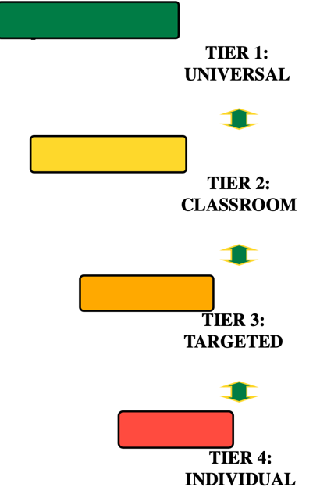

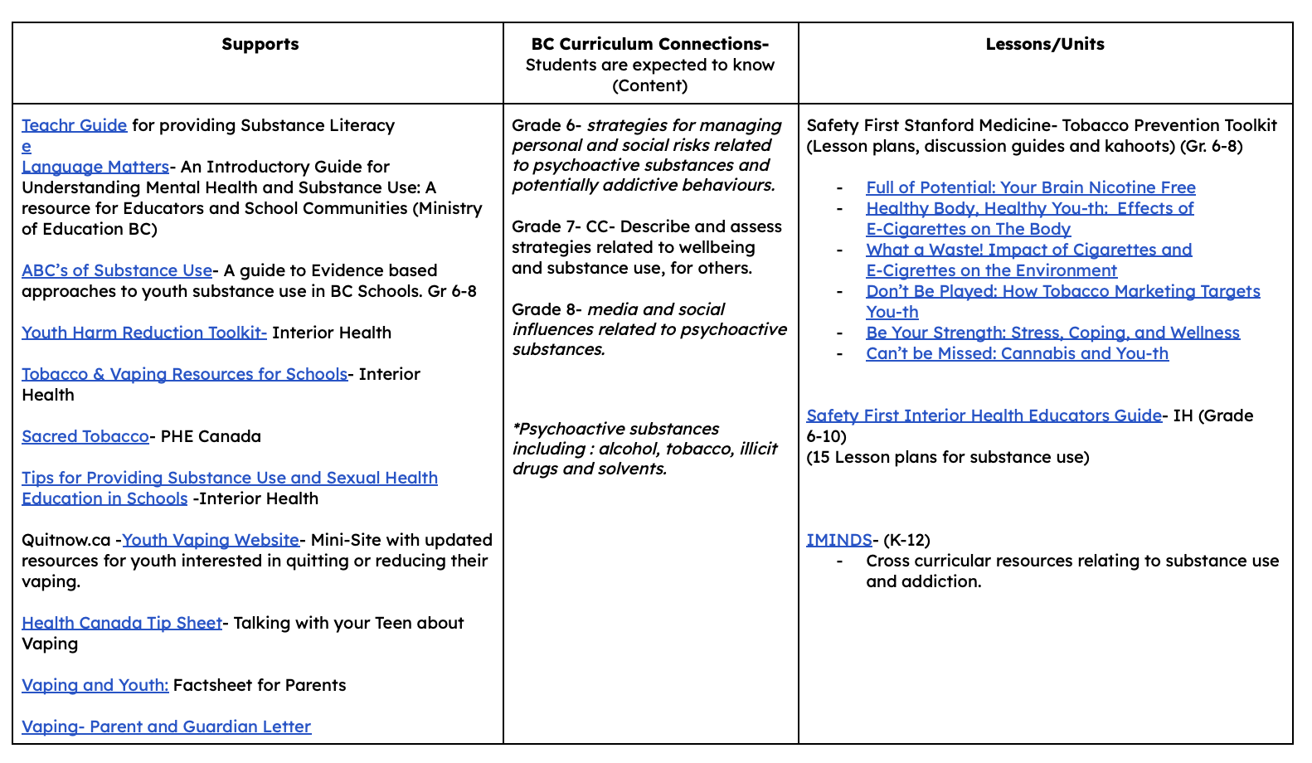

Next Meeting
- Tuesday, September 9th, 6pm

Meeting Adjourned @ 6:48pm
*general inquires for the PAC may be directed to: glenrosamiddlepac@gmail.com

