Learner Code of Conduct
At École Glenrosa Middle School we expect inclusion, value equity, promote leadership, and strive to meet the needs of our diverse learners. We thrive on the boundless energy and unique needs of early adolescents. We recognize that each student and situation is unique. We strive to ensure that our school is a safe and caring space where all members of our learning community can work and learn together.

PURPOSE OF THE CODE OF CONDUCT
This code is based on the principles of respect, rights, and responsibilities and exists to:
- Provide a foundation for the development and maintenance of a safe, caring and orderly environment for school members,
- Strike an appropriate balance among individual and collective rights, freedoms, and responsibilities,
- Outline and clarify expectations for students while at school, going to and from school, and at any school function or activity at any location.

CLOSED CAMPUS
All middle schools in Central Okanagan Public Schools are close campuses. After arriving at school, learners are expected to remain on campus for the remainder of the school day, unless signed out by a parent through the school office. Learners are NOT permitted to go to surrounding properties, stores etc. under any circumstance.

DRESS CODE
The way we dress can communicate the respect we show to others and to the school as a place for working and learning. The purpose of the GMS dress code is to clarify what clothing is reasonable for learners and staff to provide a positive school climate. Learners are asked to avoid dress styles which promote, imitate or celebrate violence, intimidation, racism, sexism, hatred towards others, gang association, sex or alcohol/drug use. Hats can be worn in the school, and by teacher discretion, may or may not be worn during class time. If clothing is determined by staff to be inappropriate, learners may be asked to change. This expectation applies to all learners. Footwear must be always worn for health and safety reasons.

Responsible Student Use of Personal Technology Devices, School Technology, and District Networks
The purpose of using network services and digital technologies while in educational settings is to engage in responsible educational activities. Therefore, the use of school technologies, and district network services requires students to abide by the school’s Code of Conduct and procedures, as well as Central Okanagan Public Schools Policy 486: Student Use of Network Services and Digital Technologies. Some examples of responsible use with district and personal devices include the following:
• Act responsibly when accessing technology and district networks, including the Internet in their school.
• Use technology, equipment and property according to all applicable rules and with care and respect.
- Engage in appropriate use as directed by school staff.
- Respect the safety and privacy of self and others and do not provide personal contact information about themselves or other students.
- Treat others with respect and kindness when using digital devices and network services.
- Respect resource limits of the network services and do not engage in activities that jeopardize the integrity, security or performance of the network.
- Understand the importance of privacy and security and take all reasonable precautions when accessing network services and digital technologies.

The use of Personal Technology Devices, School Technology, and District Networks is a privilege, and usage may be revoked at any time for inappropriate conduct. Schools will not be held responsible for any misplaced, lost, stolen, or broken items brought to school by students. Use of network services and digital technologies which violate the terms outlined in policy and/or the School's Code of Conduct may result in serious consequences including definite or indefinite suspensions and/or police intervention.

Cell Phones and Devices
Please refer to the following Central Okanagan Cell Phone policy for all middle schools in Kelowna:
Central Okanagan Public Schools
Updated Restrictions for Cell Phones and Personal Digital Devices.
In accordance with the new requirements from the Ministry of Education and Child Care, schools across our district have updated their Student Code of Conduct to include the restricted use of cell phones and personal digital devices during school hours effective July 1, 2024.

Our School Code of Conduct has been revised to reflect the new requirements regarding cell phone use in schools accordingly.
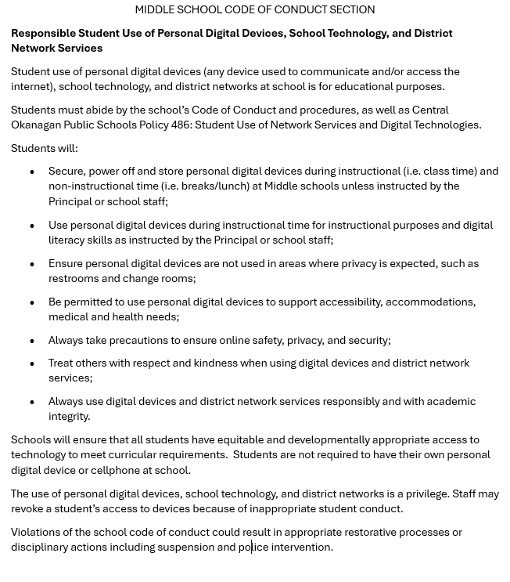

GMS Cell Phone policy – can be found here:

- Cell phones may not be used while in the building. When students enter the building, they are expected to head directly to their locker, power-down their phone, and store it in their locker until dismissal at 3:16 PM.
- Cell phone use is prohibited:
  - In the school building at all times
  - On school property (including outside fields) from 9:00 AM- 3:16 PM
- During the school day, transitions, and lunch, cell phones must remain in student lockers.
- If students need to place an emergency phone call during the day, they should request to go to the main office to use the student phone or contact their teacher to explain their situation.
- Students may be subject to disciplinary action if the use of their cell phone disrupts the school’s educational environment. Examples of this include, but are not limited to cheating, bullying, harassment, recording or sharing of student images or violating other school rules or misuse of cell phones.
- The school and its staff are not responsible for any damage to or theft of a student’s cell phone. Students must properly secure and take care of their own phones.
- Students and parents/guardians must read the cell phone policy. The policy will be in place for all students and available online through the GMS website.

If students violate the school’s cell phone policy, the following may occur:

First offense: The student will be asked to place their phone in their locker. The student must also discuss and review the cell phone policy with the staff members.
Second offense: The student will be asked to take their phone to either CONNECT or the main office. It will be held there until after dismissal. The student will discuss the cell phone policy with the administration, or a behavior support teacher, and subsequent consequences.
Third offense: The students will be asked to take their phone to either CONNECT or the main office. The phone will be held in the main office until the student’s parents are able to come to pick it up. The student may be placed on a cell phone plan.
Due to the complex nature of before school, lunchtime, and after school supervision, during these times, if students are using their phones, supervising staff will ask the student to take the phone to the main office.

**The administration reserves the right to adjust these consequences on a case-by-case basis if needed. For example, extreme behaviors that engage in bullying or harassment of other students or staff may result in suspension or a permanent ban of an individual’s device.**

Personal Property and Lockers
Learners may be assigned a locker. Learner locks and lockers remain the property of the school, and the school retains access to the lockers throughout the year. Lockers can be opened and searched when deemed necessary by school administrators. Personal locks are not to be used. In order to ensure learners' belongings are safe, lock combinations must be shared.
Learners should not bring unnecessary items, valuables, or large amounts of money to school. The school is not responsible for lost or stolen items.

Bikes / Scooters / Skateboards Learners are not to be on their skateboards, scooters, or bikes on GMS property. Unsafe and/or improper use may result in a learner being asked to not bring their skateboard, scooter, or bike to school permanently. While travelling to and from school, we recommend the use of appropriate protective equipment including a helmet. We ask that parents/guardians please discuss traffic safety with your child.
Scooters and bikes should be secured with a good lock in the racks at the school's front. Skateboards may be stored in lockers or the classroom at the teacher's discretion. We do not have alternative storage inside the building for bikes, scooters, or skateboards. The school cannot be responsible for lost, misplaced, or stolen property stored in various unsecured areas around the school.
Social Behaviors and Relationships It is not appropriate for students to engage in overt romantic or sexual behaviors.
Safe and Caring School Environments
Are free from acts of:
• Bullying, cyber-bullying, harassment, and marginalization
• Threat and intimidation
• Violence and abuse in any form
• Discrimination in any form, including race, colour, gender, gender identity and expression, religious beliefs, sexual orientation, ancestry or national origin
• Retribution against a person who has reported an incident
Do not tolerate the presence of:
• Theft and vandalism
• Intoxicating or banned substances
• Weapons or replica weapons and explosives
• Intruders or trespassers (all visitors must first report to the office)

The Code of Conduct connects to the following Rights and Responsibilities.
RIGHTS | RESPONSIBILITIES
Learners have the right to learn | Learners have the responsibility to actively participate and be responsible learners:  *Attend class consistently  *Coming prepared for class and ready to learn  *Complete learning tasks  *Seek help if needed  *Focusing on learning and not distracting others
Learners have the right to be respected | Learners have the responsibility to respect themselves, others, and the school community:  *Being polite and listening actively to others  *Being kind and inclusive  *Accepting and respecting differences  *Being honest and trustworthy  *Promptly reporting incidences of bullying, harassment or intimidation to a trusting adult
Learners have the right to be safe | Students have the responsibly to be safe and protect the safety of others *moving the building in a calm and careful manner  *Staying in designated areas  *Participating and playing safely  *Reporting dangerous situations to staff, including possession of banned items and substances
Learners have the right to  privacy and security of personal space | Learners have the responsibility to respect the property and privacy of other students, staff, and community members  *Respecting the property of others (lockers, phones)  *Respecting personal boundaries  *Asking before photographing/recording someone
Learners have the right to use learning tools, equipment and property | Leaners have the right to use equipment and property in accordance with all applicable rules, and with care  *Asking before borrowing items  *Cleaning and returning borrowed items  *Respecting spaces, furniture, and equipment

